Experiment 13
Affine Transformation
Aim:
To perform Affine Transformation on a given image using Python and OpenCV.
Procedure:
- Import the OpenCV and NumPy libraries.
- Read the input image using cv2.imread().
- Get the height and width of the image.
- Define three points in the original and transformed images.
- Apply cv2.getAffineTransform() to calculate the transformation matrix.
- Use cv2.warpAffine() to transform the image.
- Display the original and transformed images.
Program:
import cv2
import numpy as np
img = cv2.imread(r"D:\Amrita\Pictures\Screenshots\Screenshot 2026-09-30 143819.png")
rows, cols = img.shape[:2]
pts1 = np.float32([[50, 50], [200, 50], [50, 200]])
pts2 = np.float32([[10, 100], [200, 50], [100, 250]])
matrix = cv2.getAffineTransform(pts1, pts2)
result = cv2.warpAffine(img, matrix, (cols, rows))
cv2.imshow('Original Image', img)
cv2.imshow('Affine Transformation', result)
cv2.waitKey(0)
cv2.destroyAllWindows()

Input:
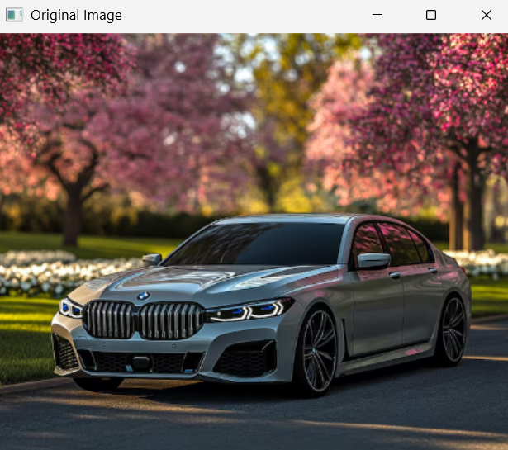
Output:
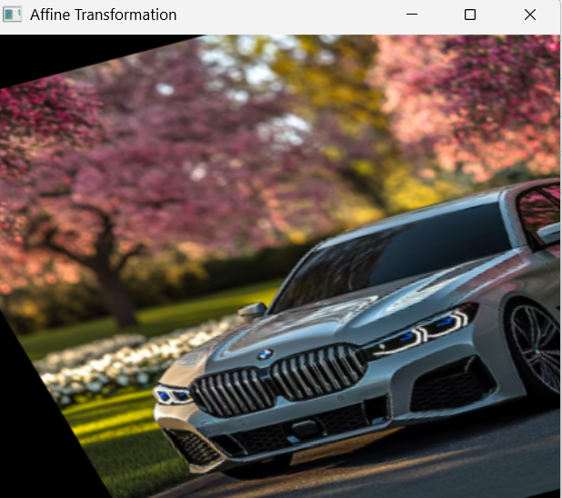
Result:
Thus, Affine Transformation was successfully performed on the given image using Python and OpenCV.

